

**Course Name**: Digital Systems Design

**Experiment**: Lab 1

**Date Performed**: 9/10/24

**Date Submitted**: 9/24/24

**Submitted by**: Nikhil Chandra, 208005066

Simulation waveform

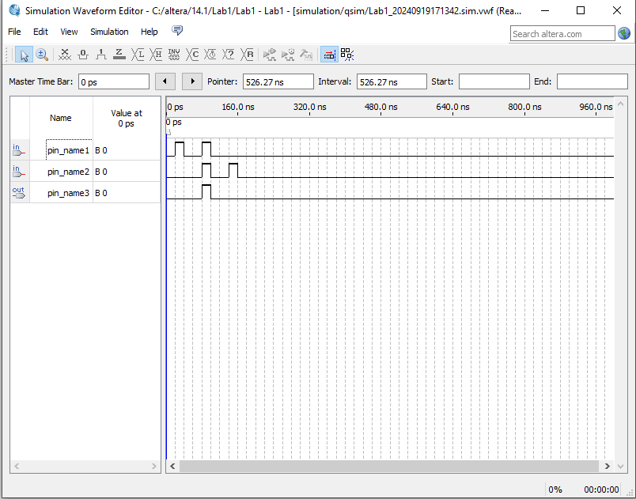

Schematic

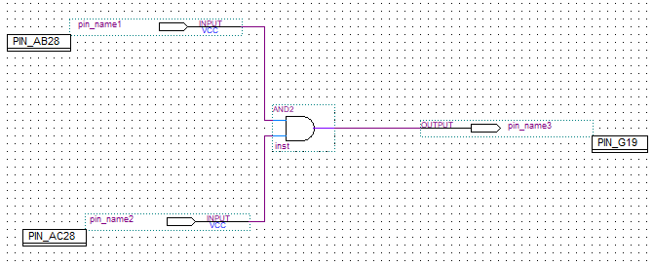

0 & 1 = 0

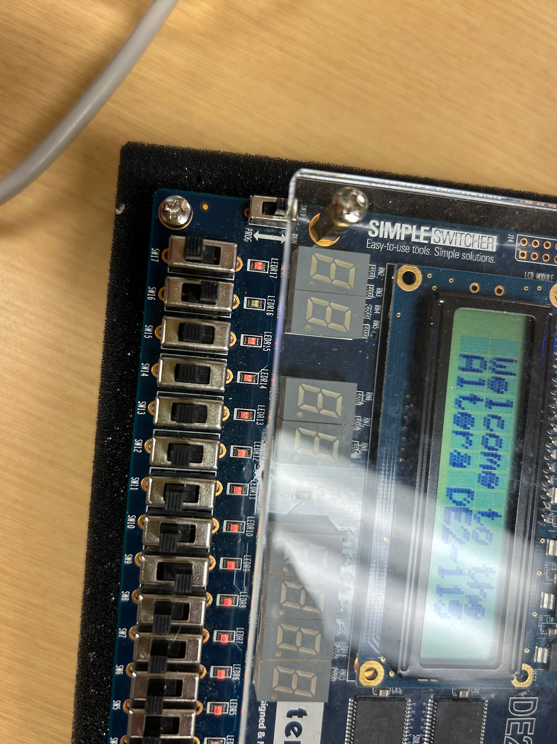

1 & 0 = 0

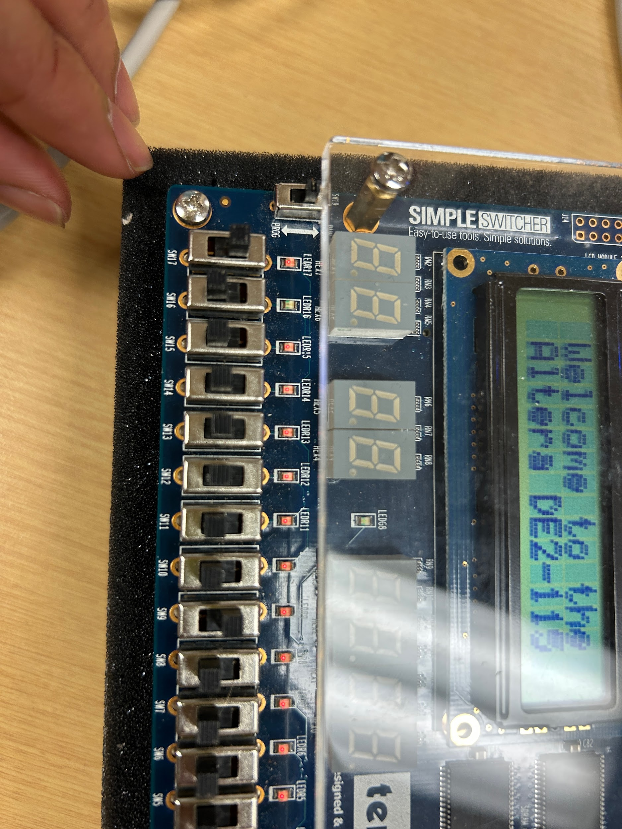

1 & 1 = 1

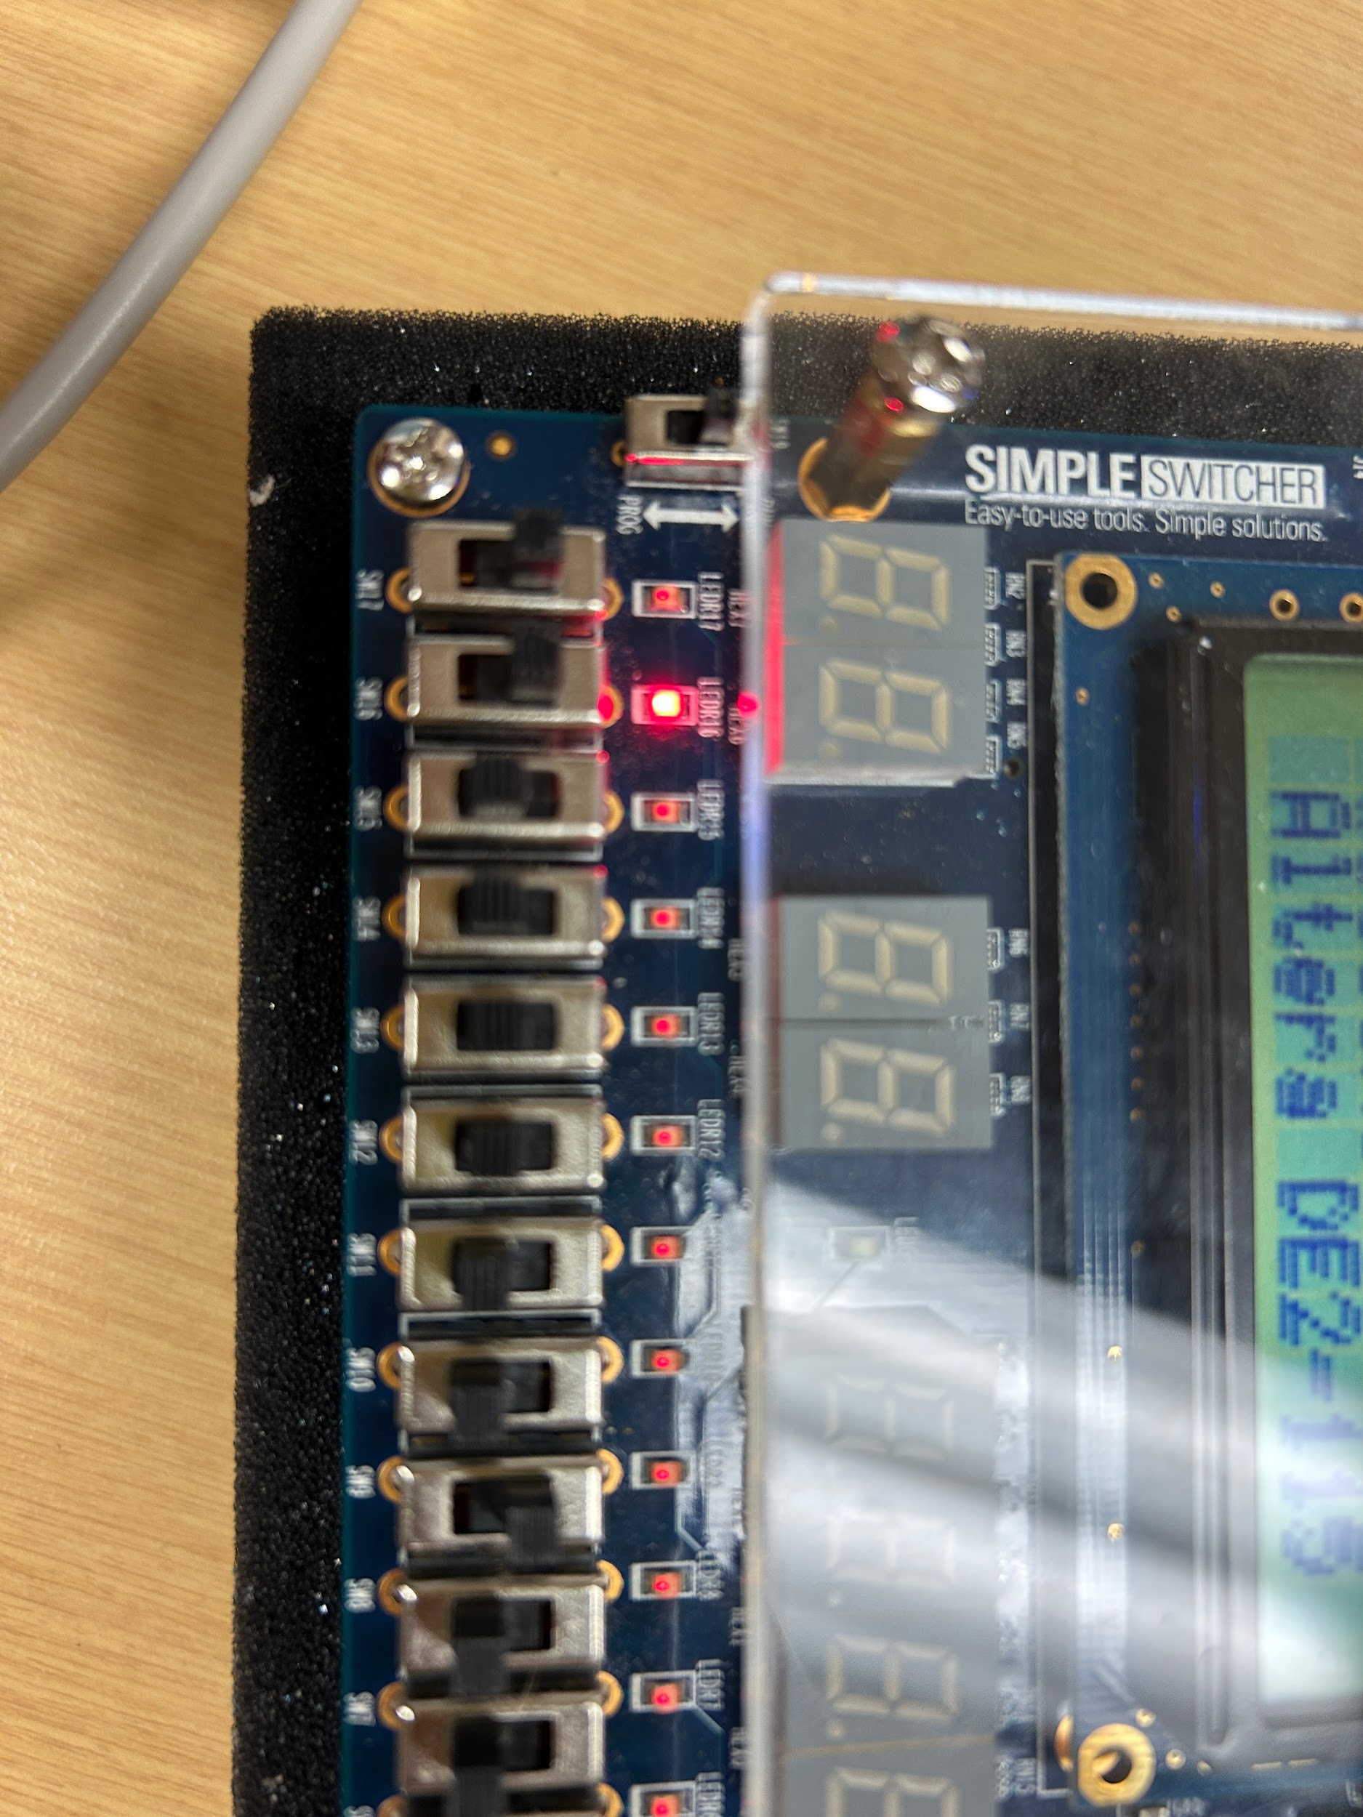

0 & 0 = 0

